### 

### Semester Two Examination, 2020

### Question/Answer booklet

# MATHEMATICS SPECIALIST

**UNITs 3 & 4**

## Section One:

## Calculator-free

|  |
| --- |
|  |

Your Name

Your Teacher’s Name

## Time allowed for this section

Reading time before commencing work: five minutes

Working time: fifty minutes

## Materials required/recommended for this section

***To be provided by the supervisor***

This Question/Answer booklet

Formula sheet

***To be provided by the candidate***

Standard items: pens (blue/black preferred), pencils (including coloured), sharpener, correction fluid/tape, eraser, ruler, highlighters

Special items: nil

## Important note to candidates

No other items may be taken into the examination room. It is **your** responsibility to ensure that you do not have any unauthorised material. If you have any unauthorised material with you, hand it to the supervisor **before** reading any further.

|  |  |  |  |  |  |
| --- | --- | --- | --- | --- | --- |
| Question | Mark | Max | Question | Mark | Max |
| 1 |  | 6 | 5 |  | 6 |
| 2 |  | 5 | 6 |  | 11 |
| 3 |  | 9 | 7 |  | 6 |
| 4 |  | 7 |  |  |  |

**Structure of this paper**

|  |  |  |  |  |  |
| --- | --- | --- | --- | --- | --- |
| Section | Number of questions available | Number of questions to be answered | Working time (minutes) | Marks available | Percentage of examination |
| Section One:  Calculator-free | 7 | 7 | 50 | 50 | 34 |
| Section Two:  Calculator-assumed | 11 | 11 | 100 | 89 | 66 |
|  |  |  |  | **Total** | 100 |

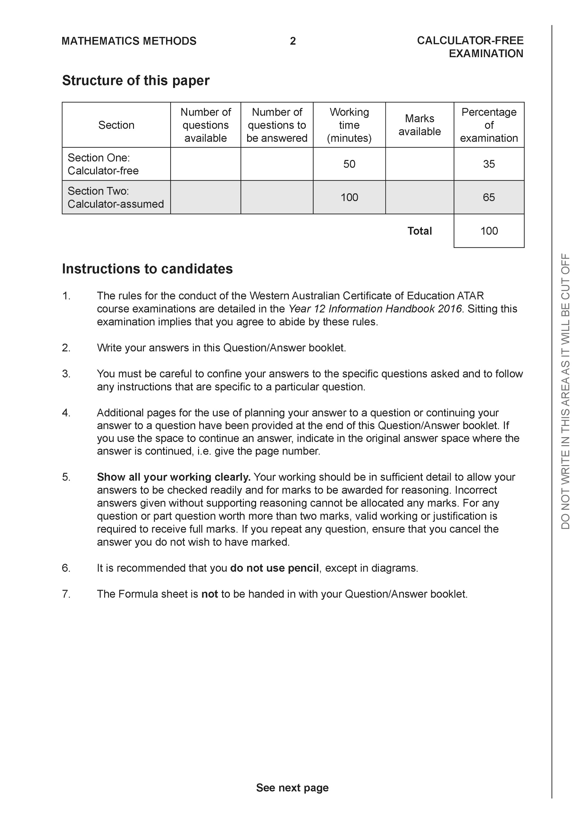

**Section One: Calculator-free (50 Marks)**

This section has **seven (7)** questions. Answer **all** questions. Write your answers in the spaces provided.

Spare pages are included at the end of this booklet. They can be used for planning your responses and/or as additional space if required to continue an answer.

● Planning: If you use the spare pages for planning, indicate this clearly at the top of the page.

● Continuing an answer: If you need to use the space to continue an answer, indicate in the original answer space where the answer is continued, i.e. give the page number. Fill in the number of the question that you are continuing to answer at the top of the page.

Working time: 50 minutes.

**Question 1 (6 marks)**

Evaluate

(a)  (3 marks)

(b)  let  (3 marks)

**Question 2 (5 marks)**

Consider the function  where  is a complex number.

1. Show that  is a factor of . (2 marks)
2. Solve for all values for in the form . (3 marks)

**Question 3 (3,4 & 2 = 9 marks)**

Given that  where  are constants.

1. Determine the values of . (3 marks)
2. Hence determine the exact value of. (Simplify) (4 marks)
3. Explain why does not exist. (2 marks)

**Question 4 (3,3 & 1 = 7 marks)**

Consider the following functions:



1. Determine  and its domain. (3 marks)
2. Determine  and its domain. (3 marks)
3. Determine the solution(s), if any for , explain. (1 mark)

**Question 5 (6 marks)**

Consider the function  which is plotted below.

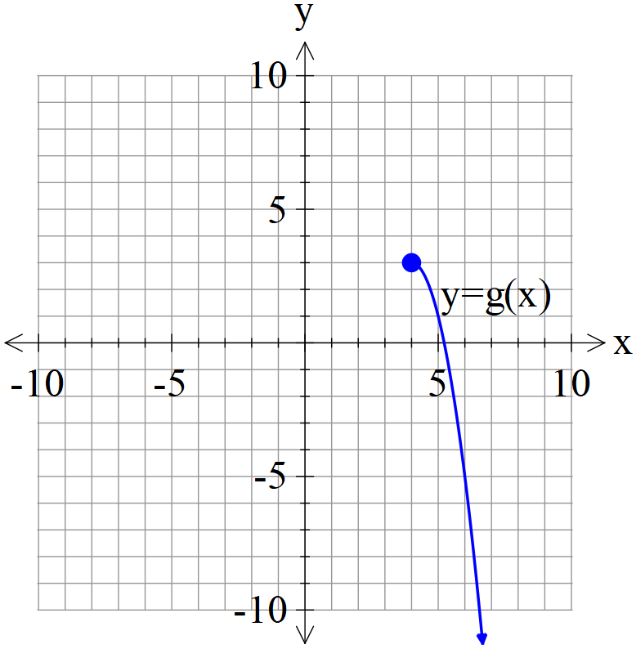

1. Plot  on the axes above showing all major features. (3 marks)
2. Given that , determine the defining rule for and its domain. (3 marks)

**Question 6 (11 marks)**

Consider the function below.

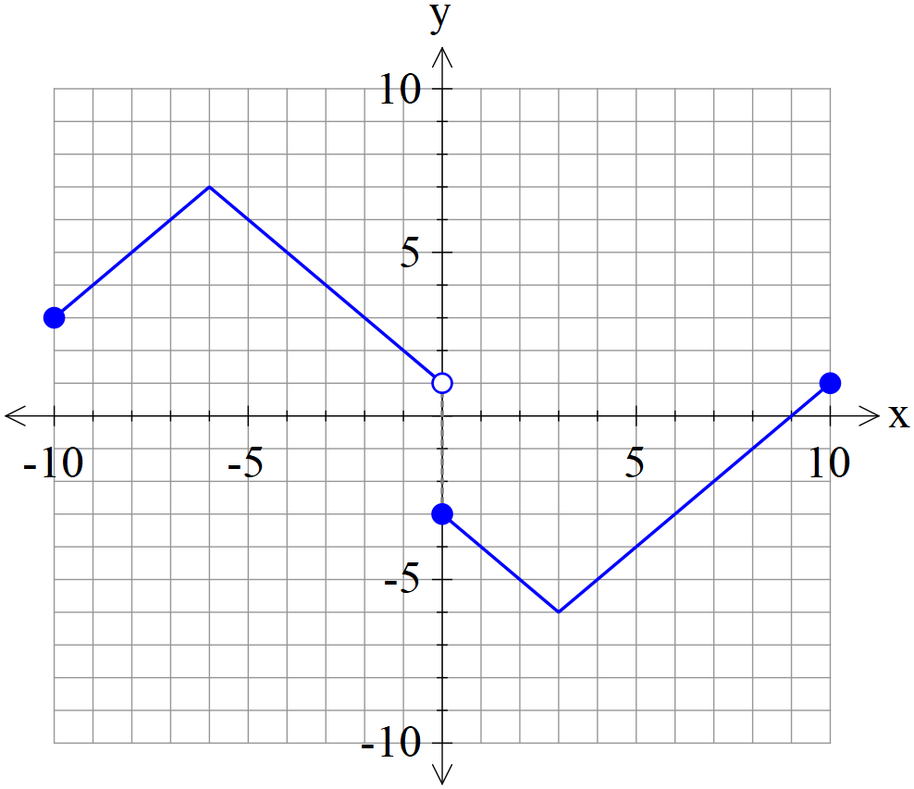

Sketch the following functions showing all major features.

1.  (2 marks)

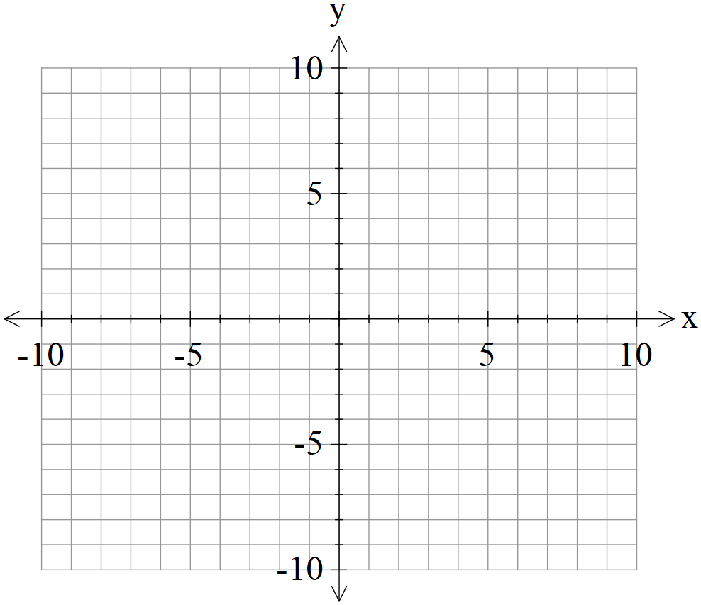

1.  (3 marks)



1.  (3 marks)



1.  (3 marks)



**Question 7 (6 marks)**

Using the substitution , evaluate the integral . (simplified)

Additional working space

Question number:

Additional working space

Question number:

Additional working space

Question number: